Pls contact us :35007117@ qq.com
----------------------------------------------
Buzzer module

Introduction
A buzzer is a great tool in your experiments whenever you want to make some sounds.

Components
- 1 * KUMAN Uno board
- 1 * Breadboard
- 1 * USB data cable
- 1 * Buzzer (Active)
- Jumper wires

Experimental Principle
As a type of electronic buzzer with an integrated structure, buzzers, which are supplied by DC power, are widely used in computers, printers, photocopiers, alarms, electronic toys, automotive electronic devices, telephones, timers and other electronic products for voice devices. Buzzers can be categorized as active and passive ones (see the following picture). Turn the pins of two buzzers face up, and the one with a green circuit board is a passive buzzer, while the other enclosed with a black tape is an active one

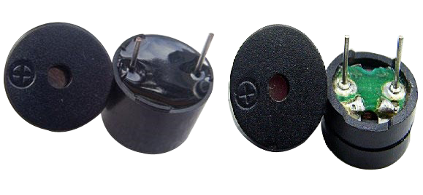
The difference between an active buzzer and a passive buzzer:
An active buzzer has a built-in oscillating source, so it will make sounds when electrified. But a passive buzzer does not have such source, so it will not tweet if DC signals are used; instead, you need to use square waves whose frequency is between 2K and 5K to drive it. The active buzzer is often more expensive than the passive one because of multiple built-in oscillating circuits.
In this experiment, we use an active buzzer.

Experimental Procedures
Step 1: Build the circuit

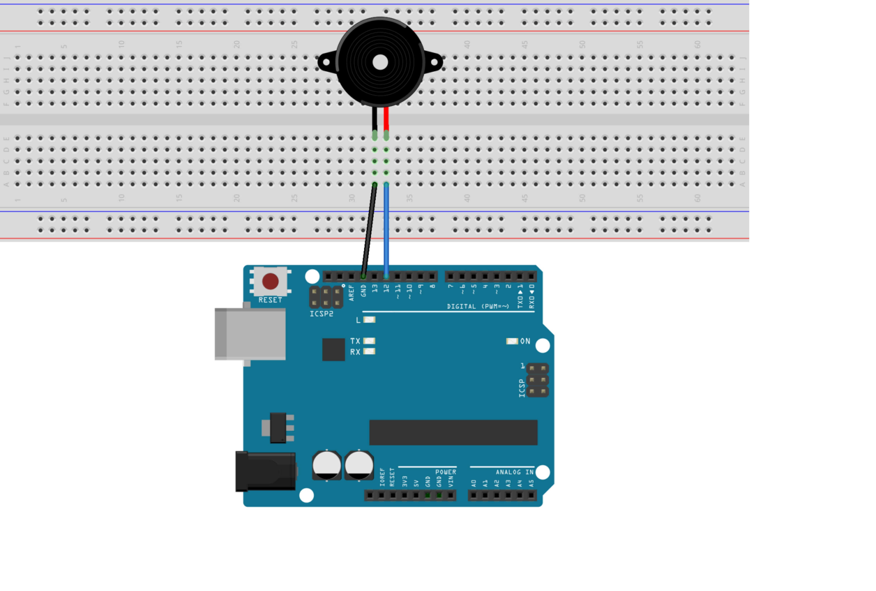

The schematic diagram:
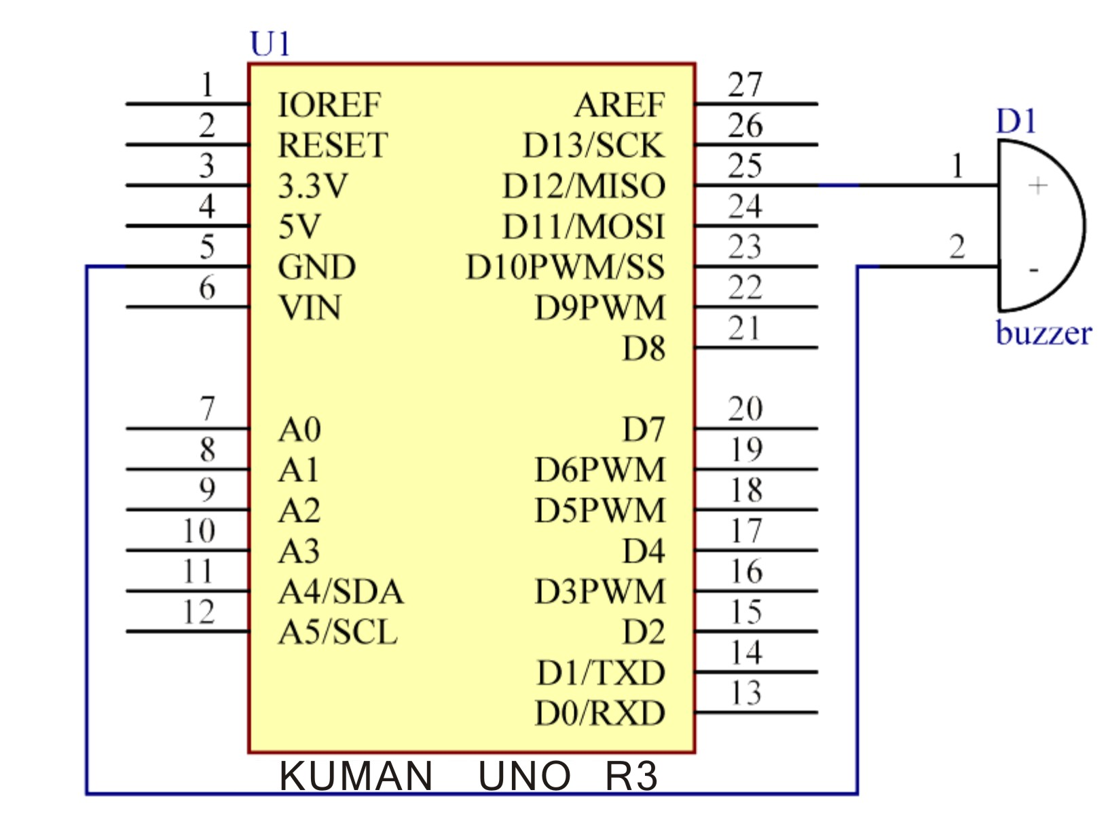
Step 2: Compile the code
Step 3: Upload the sketch to the KUMAN Uno board

Code
// Buzzer
// buzzer make sounds
//Email:350071174@qq.com
/***********************************/
int buzzer = 12;//the pin of the active buzzer
void setup()
{
pinMode(buzzer,OUTPUT);//initialize the buzzer pin as an output
}
void loop()
{
unsigned char i; //define a variable
while(1)
{
//output an frequency
for(i=0;i<80;i++)
{
digitalWrite(buzzer,HIGH);
delay(1);//wait for 1ms
digitalWrite(buzzer,LOW);
delay(1);//wait for 1ms
}
//output another frequency
for(i=0;i<100;i++)
{
digitalWrite(buzzer,HIGH);
delay(2);//wait for 2ms
digitalWrite(buzzer,LOW);
delay(2);//wait for 2ms
}
}
}
/****************************************/

